**REVIEW ARTICLE**

**TITLE: Microemulgel: A Novel approach for topical drug delivery by using Metformin HCL for treatment of melasma**

Mahima A Mudhole,Harish* K.H., Dr. Fatima Sanjeri Dasankoppa,, Dr. AHM Vishwanath Swamy

Department of Pharmaceutics, KLE College of Pharmacy, Hubballi, Karnataka, India. AConstituent unit of KLE Academy of Higher Education and Research, Belagavi, Karnataka,India.

**Corresponding Author:**

1. Harish K.H.

Associate Professor

Department of Pharmaceutics

KLE College of Pharmacy, Hubballi

A constituent unit of KAHER, Belagavi

Email ID: [harikh79@gmail.com](mailto:harikh79@gmail.com)

Contact: 9986056174

**ABSTRACT**

Melasma is an acquired hyperpigmentation characterized by bilateral irregularbrown macules and patches over sun exposed areas of face and less commonly forearms. No single treatment universally effective. It has shown been showntaht Metformin HCl could decrease intracellular cyclic adenosine monophosphate. Since cAMP has arole in melagnogenesis, metformin can inhibit melagnogenesis resulting in a significant reduction in melanin in the basal layer.

Metformin HCL having anticoagulant,antinflammatory,and antiproliferative effect. The objective of the present study was to develop formulation of metformin hydrochloride in different gel as microemulsion.

The result shows that all gel formulation showed good and acceptable physical properties. The result of the different chemical and physical test of Metformin HCL gel showed the formation could be used topically in order to protect skin damage and these formulation for better absorption and penetration of the active moiety in to systemic circulation.

In this different gelling agent can be used to formulate topical gel of Metformin HCL for long term stability study.

**Key words**: Melasma, Metformin HCl, topical treatment, microemulsion, microemulgel.

**INTRODUCTION**

**Topical drug delivery system**

Topical drug delivery products can be broadly classified as either internal or external. While the internal topicals are given to the mucous membrane orally, vaginally, or on the rectal tissues for local activity, the exterior topicals are distributed, sprayed, or otherwise dispersed over the tissue to cover the diseased area. A topical drug delivery system's main benefits include preventing first-pass metabolism, preventing gastrointestinal incompatibilities, improving patient compliance, enabling simple self-medication, and allowing for the easy termination of medications as needed. Additionally, drugs with short half-lives and narrow therapeutic indices can also be used.

Applying a dose form to treat skin conditions can be used to illustrate the topical route of drug delivery. The primary advantage of dermal application over alternative delivery routes, such as oral, sublingual, rectal, and parentral, is that it might be thought of as superior. Avoiding the first pass metabolism is the route. Many benefits come from applying medication topically, such as targeted and site-specific drug delivery. They make a substance more bioavailable.

Categorization of topical medication delivery methods

1. Solid: Plastiques, ointments, and powders .  
2. Semi-solid: Pastes, gels, creams, and poultices   
3. Liquid: paints, tinctures, lotions, solutions, emulsions, suspensions, and lotions   
4. Miscellaneous: topical aerosol, rubbing alcohol, tapes and gauzes, liquid cleanser, and transdermal drug delivery systems.

Factors influencing the drug's topical absorption

**Physiological elements**1.Thickness of the skin,Lipid composition.

1. Blood composition
2. Skin hydration
3. Hair follicle density
4. Skin inflammation
5. A medical condition
6. Sweat gland density

**Physiochemical elements:**  
1. Vehicle impact   
2. Coefficient of partition   
3. Molecular mass (less than 400 daltons)   
4. Ionisation degree (only unionised medicines absorb effectively)

**MICROEMULGEL**

Microemulgel's dual mechanism of emulsion and gel makes it one of the most promising technologies among innovative drug delivery systems. Additionally, emulsion's stability was shown to be enhanced by combining it with gel.The superior solubility and skin penetration of the microemulsion technology was the deciding factor in its selection.Oils, surfactant, and co-surfactant screening is necessary for the manufacture of microemulgel.*Because of their ability to enhance topical and systemic availability and solubilize poorly soluble drugs, micro-emulsions—optimally isotropic and thermodynamically stable systems of water, oil, surfactant, and/or co-surfactant—have been investigated as drug delivery vehicles. Its solubilization of the lipophilic drug moiety aids in its quick and effective skin entry. Therefore, it helps with topical medication administration.

Significance of microemulgel

Numerous common topical medications, such as lotions, ointments, and creams, have a number of drawbacks. They have a lower spreading coefficient when applied by rubbing, which makes them uncomfortable for the patient, and they also have stability issues. The usage of translucent gels in pharmaceutical and cosmetic preparations has increased as a result of all these aspects falling under the larger category of semisolid preparations.

Gel base can be used with the emulsion. Instead than just adding medications to a gel foundation, this could provide the medication with better stability and release.

Emulgel is a relatively new technology that has dual control release characteristics and is utilised topically. Emulgel is a combination of gel and emulsion that has both of these characteristics. They refer to this combination of emulsion and gel—which is primarily hydrophobic as well as hydrophillic—as an emulgel.

Emulgels are excellent candidates for the topical administration of lipophilic medications. Lipophilic medications are entrapped in oil with an aqueous phase, while lyophilic pharmaceuticals are loaded in an oil phase with water. Topical illnesses are treated using emulgel.

OBJECTIVE

* To increase patient compliance

 Better stability

 Controlled release of drug

 superior loading capacity

 production utility

 low preparation cost

 non irritant.

Advantages of emulgel

 Incorporation of hydrophobic drugs

 Superior loading capacity

 Better stability

 No intensive sonication

 Controlled release

 Production utility and low preparation cost

Formulation of emulgel

For the preparation of emulgel some consituents are used including drug, they are:

• **Vehicle**: Vehicle should follow the ideal characters given in the pharmacopeias. Deliver

the drug to the target site.

• **Aqueousmaterial**: The aqueous phases used are water, alcohol etc.

• **Oil**: These are used in preparation of emulsion. This medium is required for dispersing

hydrophobic drugs.

• **Emulsifying agents:** These are employed for the purpose of emulsifying aqueous and oil

medium for stability purpose. Emulsifying agent are maintain the stability while they

thermodynamically unstable.

• **Gellingagent**: Gelling agent are employed for gel formation that is intended for

dispersing in for altering thixotropy characteristics.

• **Penetration enhancer**: These substances help in increasing permeation characteristics of drug so that it passes across skin.

**Constituents of emulgels**

|  |  |
| --- | --- |
| Aqueous material | Rose water, sterile water, Alcohol. |
| Oils | Castor oil,Mineral oil,Balsam oil,linseed oil. |
| Emulsifiers | Tween 80,Tween 20,Span 20,Span 80,PEG400,600. |
| Gelliing agent | Carbomer 934,934p.940, HPMC,CMC |
| Penetration enhancer | Propylene glycol,Clove oil,isopropy myristate,olive oil,urea,oleic acid. |
| pH adjusting agent | NaoH,Triethanolamine. |

**Method of preparation of emulgel**

Step 1 is to formulate the emulsion, either water-in-oil or oil-in-water.   
Step 2: Gel base preparation.  
Step 3: Quickly and thoroughly mix the emulsion into the base.   
  
The temperature of the water medium and oil phase was raised to roughly 75 °C. The oil medium was then added to the water medium. Stirring was done continuously until the mixture cooled to room temperature. As a cross-linking agent, glutaraldehyde was used.

Steps involved in preparation of emulgel

Oil phase

Aqueous phase

Emulgel

o/w or w/o Emulsion

Incorporation of gel base

Emulsification

**MELASMA**

Melasma is an acquired hyperpigmentation characterized by bilateral irregular brown macules and patches over sun-exposed areas of face and less commonly, forearms. No single treatment is universally effective. It has been shown that metformin could decrease intracellular cyclic adenosine mono phosphate. Since c-AMP has a role in melanogenesis, metformin can inhibit melanogenesis resulting in a significant reduction in melanin in the basal layer.

Melasma is a pigmentary disease that develops over time and typically affects women who are fertile. It is characterised by symmetrical, hyperpigmented macules and patches over the face, neck, and infrequently the forearms.

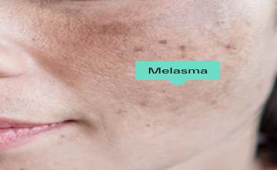  
The range of its prevalence is 1.5% to 33.3%. Melanocytosis and enhanced melanogenesis as a result of upregulated genes related to melanin biosynthesis, such as microphthalmia-associated transcription factor (MITF) and tyrosine-related protein-1 (TYRP1), are the main causes of hyperpigmentation. Other contributing factors include genetic predisposition, UV exposure, thyroid disorders, pregnancy, and medications like phenytoin and contraceptive pills.

Because melasma is resistant and recurrent, treating it can be frustrating for both patients and doctors. Hydroquinone, the Triple Therapy Combination (TCC), which combines hydroquinone, steroid, and tretinoin, kojic acid, azelaic acid, arbutin, vitamin C, chemical peeling, lasers, tranexamic acid, rucinol, oligopeptides, silymarin, orchid extracts, and botanical extracts are among the treatment modalities for melasma that have been tried, with varying degrees of success.

**Metformin hydrocloride for treatment of melasma** The anticoagulant, anti-inflammatory, and anti-proliferative properties of metformin hydrochloride may influence wound healing or the likelihood of wound complications following surgery or trauma. Developing metformin hydrochloride formulations in various gel bases, such as alcoholic, hydrogel, microemulsion, anhydrous, and hydroalcoholic gel, was the aim of the current work. The outcome demonstrates that every gel formulation had favourable and good physical characteristics. The information gathered from the release study showed that the type of base had an impact on the overall amount of drug release. The bases with the highest drug release were alcoholic, hydrogel, hydroalcoholic, anhydrous, and microemulsion gel. According to statistical analysis, the first three gel bases' greater release rate was noteworthy in comparison to the anhydrous and microemulsion gel bases. The metformin hcl gel's performance in several chemical and physical tests indicated that it may be applied topically to prevent skin damage and that its formulation would improve the active moiety's absorption and penetration into the systemic circulation. In accordance with ICH recommendations, a separate gelling agent can be utilised to create a topical gel of metformin hydrochloride for long-term stability studies.

**Materials and Methods involved in Microemulgel**

Identification of API: As per pharmacopoeia procedure.

Scanning and Calibration curve of API in solvent and in Phosphate buffer at specific pH: As per pharmacopoeia procedure.

Identification of Excipients: As per pharmacopoeia procedure.

Short listing of oils that have no interference of absorbance of API (generally between 200 and 400 nm.)

Screening of oil among the shortlisted oils, emulsifier and co-emulsifier on the basis of solubility study.

Selection of emulsifier, co-emulsifier, its ratio and oil.

API-Excipients compatibility study.

Preparation of Pseudo ternary phase diagram.

Application of Mixture design.

Preparation of API loaded micro-emulsion.

Optimization of micro-emulsion: By design expert 9.0.3.1 software or Minitab 7.0.

Formulation and Development of API loaded microemulgel using suitable design of experiments.

**Formulation considerations**

**Selection of oil phase**

The lipophilic bioactive molecule may dissolve in carrier oil, which makes up the oil phase. Low molecular weight oils, such as triglycerides, are preferred in microemulsion formulation over high molecular weight oils because they are cosurfactant surfactants that can permeate the interfacial film and improve the creation of an ideal curvature of the interfacial film.

Oil phase chosen for microemulsion based gel formulation is the oil exhibiting excess drug solubility. These lipids might have a high solids to mobile liquid consistency. There is no need to add penetration enhancer to a microemulsion delivery system because the lipid phase occasionally functions as one.

**Selection of surfactants and co-surfactants**

The second criterion for selecting surfactants was based on their capacity to create microemulsions with specific lipids that had the best medication solubility . Surfactants are unit active molecules with a structural structure that consists of both a lipotropic and hydrophilic domain . Surfactants' amphiphilic properties allow two incompatible phases to disperse, raising surface tension and creating a flexible enough film to bend around droplets with the optimal curvature.

The majority of cosurfactants are polyglycerol derivatives and short- to medium-chain alcohols, such as ethanol, isopropanol, isopropyl myristate, and propylene glycol (PG). Low irritancy cosurfactants have also been produced by nonionic surfactants. To reduce the interfacial tension to a temporary negative value, cosurfactants and surfactant are employed. Fine droplets are produced at this negative value as a result of the interface expanding, and more surfactant or cosurfactant is adsorbed on the surface until the bulk condition is sufficiently reduced to return the interfacial tension to a positive value.

**Selection of gelling agent**

By introducing gel phase, the gel structure is provided in the formulation. There are two kinds of artificial and natural. A formulation becomes thixotropic when a gel phase is added. In O/W microemulsions and nanoemulsions, the thickening agents are used to balance the density of the oil component with the surrounding liquid component. As a result, by focusing on the effects of attraction forces, they may lessen the frequency of deposit phenomenon or creaming.

Preservative agents are typically required in water-based systems in order to prevent the growth of germs. Preservatives are usually added extra in the particular instance of EO-based systems because EOs are naturally existing antimicrobials. The work demonstrates that the antibacterial agent nisin was encapsulated using an EOs-based microemulgel. Through the synergistic effect of nisin and EOs, rosemary, thyme, oregano, and herbaceous plant EOS were the best to increase the system's overall antimicrobial activity.

**Drug excipient compatability studies**

Using a Perkin Elmer FTIR spectrometer, the FTIR analysis was conducted to look for any suspicious interactions that would have an impact on the drug's stability, efficacy, or the excipients selected for the creation of microemulgel. The study covered a range of 4000-400 cm-1.

**Screening of excipients by solubilities studies**

For solubility tests, a variety of oils, such as oleic acid, liquid paraffin, propylene glycol, and surfactants like tween 80 and tween 20 were tested. A surplus of medication was introduced to various oils and surfactants. The mixture was centrifuged for 15 minutes at 1000 rpm after being constantly agitated in a Rotary Shaker for 72 hours at room temperature.   
After being decanted off, the liquid supernatant was filtered using a membrane filter. After extracting 1 millilitre of the filtrate, 1000 millilitres of methanol were added. The diluted samples were seen in the UV-Vis spectrophotometer at a wavelength of 283 nm. By comparing the concentration of the sample soluble in various oils and surfactants with a standard calibration curve.

**Construction of pseudo ternary diagram in microemulsion**

The objective of the study was to investigate the behavior of ternary phase diagrams

consisting of water, oil, and surfactant. The researchers aimed to identify and characterize the different phases obtained from combinations of oil and surfactant/cosurfactant mixtures (Smix), including conventional emulsions, gel/viscous phases, and transparent/translucent nanoemulsions (NEns).

In this study, OFIS oil, Tween-80 (a non-ionic surfactant), and PEG-400 (a co-surfactant) were used to create ternary phase diagrams that looked at the production of NEns. Finding the right ratio of surfactant to co-surfactant to produce a large existence area of the NEn phase was the aim.[8] During the experiment, Tween-80 was mixed with PEG-400 in the following ratios:1:0.5,1:1,1:1.5,1:2,1:2.5, and 1:3. In the ternary phase diagrams, these mixtures functioned as the surfactant and co-surfactant components.

Water was gradually added to the oil surfactant-co-surfactant solutions while being violently stirred using a vortex mixer in order to generate the phase diagrams. Using the water titration approach, the concentration of the surfactant-co-surfactant mixture was lowered and the water content of the system was raised. Room temperature was used for this procedure. The resulting mixes were visually inspected and classified as clear NEns, emulsions, or gels following each addition of water. The phase in which the mixtures were located on the phase diagram was established by their observed behaviour.

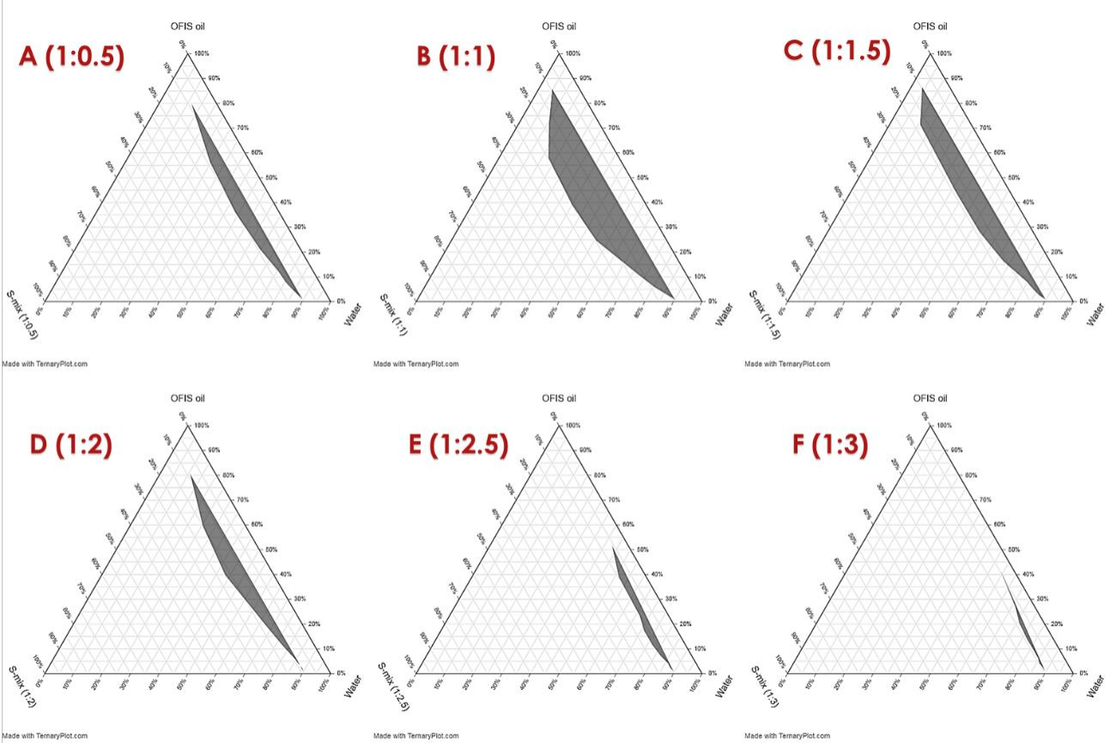

**Preparation of microemulsion**

A magnetic stirrer was used to precisely weigh and dissolve a preset amount of medication in oil. The surfactant was combined with water. Drop by drop, this mixture was added to an oily drug solution, and the mixture was mechanically agitated to create an emulsion. Drop by drop, co-surfactant was applied to the emulsion. The appearance of the translucent solution signalled the beginning of the microemulsion.

**Preparation of microemulgel**

For a whole day, each gelling agent was presoaked individually in the aqueous phase (water). To create a microemulsion-based gel, the prepared oil phase, or microemulsion, was then added to the gel phase and stirred until a smooth, attractive microemulgel was produced.

**Evaluation of microemulsions**

1. **Droplet size measurement** Zetasizer (Malvern Instruments Ltd., Malvern, U.K.) is used in dynamic light scattering to analyse the size of microemulsions. Using the same tool, the formulation's polydispersity index was calculated.
2. **Zeta potential measurements**

This is employed to determine the droplet change. Due to the existence of free fatty acids, an oil droplet in a typical emulsion has a negative charge. Zetasizer is used to calculate the microemulsion's zeta potential.

1. **Conductivity measurement**

A quantitative understanding of the solubilization of the water phase in the chosen mature containing the oil phase, surfactant, and co-surfactant is provided by the measurement of electrical conductivity. It also provides information on the many kinds of microemulsion. According to the optimised formulation, the concentrations of the oil, surfactant, and cosurfactant are chosen. Subsequently, the water phase is gradually added to the oil and amphiphile combination, and the resulting formulation's electrical conductivity is measured at room temperature with a conductometer.

1. **Transmission electron microscopy**

TEM, 20–200 kv accelerated voltage Philips Technai-20 electron microscope (Philips, Holland). Phosphotungestic acid (PTA) in an aqueous solution at a concentration of 1% was used to adversely stain the samples. On a copper grid covered in carbon, the microemulsion was dried. The samples were examined under an 80 kV microscope after drying.

**Evaluation of microemulsion based gel**

**Physical appearances**

The microemulgel formulations that were created were visually inspected to assess their homogeneity, phase separation, consistency, grittiness, colour, and appearance. Phase separation, grittiness, and consistency.

**Extrudability [Tube test]**

The purpose of the test is to figure out how much force is needed to extrude the material from the tube. The collapsible tubes were filled with the mixtures.   
The formulation's extrudability was assessed by measuring the weight needed to extrude a 0.5 cm microemulgel ribbon in 10 seconds. Extrudability is said to be improved when there is a greater extrusion volume. A calculation and record of the proportion of gel extruded were made.

**Synersis measurement**

Following a visual inspection, the microemulgel was examined to check for potential phase separation. Sometimes, when gel is left to stand, very little liquid is forced out. We refer to this phenomena as syneresis.   
Percent syneresis is how it is expressed. The centrifuge is a tool used in this test. The mixture was added to a cylindrical tube covered in Whatman filter paper and featuring a perforated bottom. After inserting the tube into the centrifuge, it was spun for fifteen minutes. The liquid and tube that were taken out of the microemulgel were weighed. Formulas were used to calculate the percent syneresis.

**pH**

A pH metre (Digital pH metre) can be used to measure the pH value. Prior to use, the pH metre was calibrated using a standard buffer solution with pH values of 4 and 7. After that, the prepared Microemulgel's 1% aqueous solution can be made. After dissolving the necessary amount of formulation in distilled water and stirring it to create a homogenous suspension, it was set aside for two hours. Using a digital pH metre, one may measure the suspension's pH

**Rheological study**

The viscosity of the microemulgel was measured with a viscometer made by Brookfield.

**Drug content determination**

Drug content in microemulgel will be measured by dissolving 1gm of microemulgel in solvent by sonication. Absorbance will be measured after suitable dilution at λmax nm using UV spectrophotometer

**In vitro diffusion study**

Franz diffusion cell (with effective diffusion area 3.14 cm² and 15.5ml cell volume) is used for the drug release studies. Microemulgel is applied on to the surface of cellophane membrane. The cellophane membrane is clamped between donor and receptor chamber of diffusion cell. The receptor chamber is filled with freshly prepared PBS (pH 5.5) solution to solubilise the drug. The receptor chamber is stirred by magnetic stirrer. The samples are collected at suitable time interval sample are analyzed for drug content by UV visible spectrophotometer at respected wave length after appropriate dilutions. Cumulative corrections are made to obtain the total amount of drug release at each time interval. The cumulative amount of drug release across the cellophane membrane is determined as a function of time.

**Release kinetics**

Drug release from all the batches of the microemulgel was evaluated for best fit model. Various kinetic models are zero order, first order, Higuchi, and Korsmeyer Peppas.

**Stability studies**

Stability study for the optimised batch was carried out as per ICH guidelines. Short term accelerated stability of gel was carried at 40°C ± 2°C /75% ± 5% RH for 3 months.The microemulgel formulation were tested and checked at regular intervals for changes in Physical appearance , consistency , pH ,viscosity , Spreadability , and drug content.

**CONCLUSION**

The topical gel's qualities are the subject of the current study and formulation. It was discovered that the gel created using metformin hydrochloride has good gel qualities in terms of homogeneity, pH, viscosity, and antibacterial activity.   
Several gel tests, both chemical and physical, revealed that the formulation may be applied topically to prevent skin damage. as well as their composition for enhanced absorption and

penetration of the active moiety into the systemic circulation in this different gelling agent can be used to formulate topical gel of metformin hydrochloride. long term stability studies as per ICH guidelines.

Topical metformin is a novel,safe,and almost as effective modality as tcc to treat melasma.

**ACKNOWLEGEMENT**

I would like to thank our professors at Department of Pharmaceutics, KLE college of pharmacy. Hubballi -580031, A constituent unit of KAHER, Belagavi for providing us with valuable guidance at insights throughout the process of writing this review. I would also like to extend warm regards to the Principal, KLE College of Pharmacy, Hubballi- 580031 for providing this opportunity and platform for doing more literature review.

**CONFLICT OF INTEREST:**

The authors declare that there is no conflict of interest.